 | 9th International Conference  MINING AND ENVIRONMENTAL PROTECTION  May 2023, Serbia

Possibilities for Reduction of Energy-Related Air Pollution in Serbia - Exploring Energy Scenarios

Marija Živković¹, Boban Pavlović¹, Dejan Ivezić^{1,} Aleksandar Mijatović¹
¹ University of Belgrade, Faculty of Mining and Geology, Belgrade, SERBIA, marija.zivkovic@rgf.bg.ac.rs

Abstract: Fossil fuels and biomass account for almost 93% of the total primary energy supply in Serbia. Meeting the energy needs of consumers implies a transformation of the chemical energy of fuels through combustion processes to obtain heat that can be utilized as such, or further transformed into mechanical or electrical energy. These processes have an undeniable impact on air pollution, even in cases of biofuels or hydrogen combustion. Possibilities for air pollution reduction are identified, both on the supply and demand sides. For exploring the effects of the implementation of energy efficiency measures and fuel switching in final energy on possibilities for the reduction of air pollution, three scenarios (low, medium, and high ambitious) of the development of the Serbian energy sector were created in the LEAP (Low Emissions Analyses Platform) modeling tool. The obtained results showed that outcomes of Serbia's energy transition will undoubtedly reflect on air pollutant emissions (carbon monoxide, nitrous oxides, sulfur dioxide, and GHG), suggesting boundaries of expected outcomes in the future, and providing values of environmental indicators.

Keywords: air pollution, scenarios of energy development, Serbia

- INTRODUCTION

Air pollution is a rising problem that is mainly induced by energy consumption and energy transformation processes. Combustion of fossil fuels such as coal, oil, gas, and even biofuels or hydrogen releases harmful pollutants into the air. These pollutants include sulfur dioxide, nitrogen oxides, carbon monoxide, and particulate matter.
The ongoing energy transition implies the transformation of present energy systems towards increased usage of renewable energy sources (RESs) and higher energy efficiency of systems [1, 2]. European countries have been working towards a comprehensive energy transition for many years, with a focus on reducing greenhouse gas emissions and increasing the share of renewable energy in the energy mix. The European Union's Energy Union strategy aims to create a secure, sustainable, and competitive energy system that delivers affordable energy to all citizens, while reducing greenhouse gas emissions to mitigate climate change [3].
One of the key elements of the energy transition in Europe is the reduction of air pollution. The European Union has set ambitious goals to reduce air pollution and improve air quality, with the ultimate aim of achieving a zero-pollution environment. The European Union has set several targets to reduce air pollution by 2030, including reducing the number of premature deaths from air pollution by 55% and reducing greenhouse gas emissions by 55% compared to 1990 levels [4]. Many European countries have also implemented their own measures to reduce air pollution, such as introducing low-emission zones in cities, promoting electric vehicles, and investing in renewable energy.
The goals of Serbia's energy policy and the ways in which they will be achieved are determined by the Energy Law. Policies related to the use of renewable energy sources and energy efficiency are also defined through separate laws, such as the Law on the Use of Renewable Energy Sources and the Law on Energy Efficiency [5, 6]. The Climate Change Law [7] is also significant for the energy transition policy in Serbia.
A prominent place among the proclaimed strategic goals is the energy transition towards sustainable energy, which involves creating economic, industrial, and financial conditions for increasing the share of energy from renewable sources. This also includes establishing institutional, financial, and technical prerequisites for using new sources of energy such as wind, solar, biomass, biogas, etc. Furthermore, improving the state and environmental protection system, establishing more favorable legal, institutional, and logistical conditions for dynamic investment in energy are important steps in achieving these goals [8].
In addition to the national energy policy framework mentioned above, Serbia ratified the Energy Community Treaty in 2006 [9], becoming a signatory to the Treaty. Through this, Serbia has committed to implementing and harmonizing the EU legal framework in the field of energy, energy transition, climate, environmental protection, market conditions, and others.
Regarding the latest harmonization with the EU policy, which also includes energy transition, it should be emphasized that Serbia has taken the obligation to develop a National Energy and Climate Plan by 2030. This plan will provide more precise definitions of goals related to the decarbonization of the energy system, increasing the share of renewable energy, reducing the impact on the environment, and achieving greater energy efficiency.
To develop effective energy strategies, it is essential to have a deep understanding of the national energy sector. Energy modeling plays a critical role in supporting energy strategies for national energy sectors to reduce air pollution and impacts on climate change. It involves determining the future demand for energy, as well as the type and source of energy that will be used to meet that demand. By developing energy scenarios, the impact of different energy consumption patterns on air pollution can be assessed.
The objective of this study is to examine possibilities for the reduction of energy-related air pollution in Serbia by assessing the potential effects of energy efficiency measures and fuel switching in both the final energy sector, in order to determine the extent to which such interventions can reduce air pollution. In this regard, three different scenarios have been analyzed, each of which makes certain assumptions about the development of the Serbian energy sector. The remainder of the study has been divided into three sections, which cover methodology and materials, results and discussion, and finally, conclusions.

2. MATERIALS AND METHODS

2.1 Energy modeling

Energy modeling is a process of creating mathematical models that simulate the energy flows within a given system. These models help to identify potential areas of energy savings, evaluate the impacts of different energy policies, and forecast energy demand and supply over time. In the context of national energy sectors, energy modeling can provide valuable insights into how energy systems can be optimized to reduce negative impacts on local air quality.
The Low Emissions Analysis Platform (LEAP) is a software platform that allows users to create detailed models of energy systems at the national, regional, or local levels. These models can be used to analyze energy demand, supply, and emissions, and to evaluate the impact of different policies and technologies on air pollution [10].
LEAP offers a wide range of features, including the ability to model different energy sectors (e.g., electricity, transport, industry, buildings), track emissions of greenhouse gases and air pollutants, and evaluate the cost and benefits of different policies and technologies. The tool is particularly useful for assessing air pollution because it allows users to model emissions of a wide range of air pollutants, including particulate matter, nitrogen oxides, sulfur dioxide, and volatile organic compounds. These pollutants can have significant impacts on human health and the environment, and reducing their emissions is a key priority for many countries.
Overall, LEAP is a valuable tool for policymakers, researchers, and analysts who are interested in understanding and addressing the complex challenges associated with energy and air pollution. By using LEAP to model different scenarios, users can gain insights into the most effective policies and technologies for reducing emissions and improving air quality [10].

2.2 Main assumptions for scenario development

The development of scenarios of the Serbian energy sector is based on the effects of two main drivers on energy consumption: GDP growth rate, and projection of population.
Serbia's GDP growth rate has averaged 2.9% over the two decades of the 21st century, which is slightly higher than the global growth rate of 2.8%. The negative GDP growth rate of Serbia in 2020 due to the COVID-19 crisis (-0.9%) had an impact on Serbia's weaker statistical growth rate in the second decade. [11].
For defining scenarios for energy development for the upcoming period, an assumption of slightly higher annual growth rates than those achieved in the period 2001-2020 has been adopted. A growth rate of 3% on average annually is assumed, with slightly more intensive growth rates (higher than 3%) in the period up to 2035 and slightly lower rates thereafter [11].
The number of inhabitants, age structure, and level of education affect the economy's structure and its future development. Moreover, the number of inhabitants and the average number of inhabitants per household are among the main factors determining energy consumption in households. Demographic projections necessary for considering future expected consumption rely on the results of the 2011 and 2022 Census and projections of changes in the number of inhabitants [12]. The projection of the Statistical Office of the Republic of Serbia, assuming a medium fertility rate, has been adopted.

2.3 Energy demand of end consumers – Final energy consumption

Based on the need to reduce greenhouse gas emissions from the energy sector, while considering the main guidelines related to the security of supply, increasing domestic production from Serbia's potential, with an emphasis on using renewable energy sources, reducing energy losses, and increasing energy efficiency, three scenarios were considered that differ in the extent of greenhouse gas emissions reduction.
The uncertainty in the global energy sector, caused by geopolitical and economic factors, also affects the development of individual countries' energy systems. In these conditions, which are accompanied by price uncertainty and the impact on the availability of energy sources that are imported, the main goal is to ensure the supply of end consumers.

To ensure a secure energy supply in different circumstances, the expected energy needs of end consumers were considered throughout three scenarios:
- Scenario “Business as usual” (BAU) assumes higher final energy consumption with low ambitions for energy efficiency measures and renewable energy use.
- Scenario “A” assumes moderate ambitions for energy efficiency measures and the use of renewable energy sources.
- Scenario “S” assumes lower final energy consumption with high ambitions for energy efficiency measures and renewable energy use.
This approach allows determining the expected range of final energy consumption and the annual needs for each energy source in the final energy consumption. Additional assumptions used in the development of scenarios are shown in Table 1.

Table 1. Additional assumptions in the development of scenarios for final energy consumption sectors
Sector | Scenario BAU | Scenario A | Scenario S
Household | Continuation of the historical trend of increase in the residential space area, changes in the number of households, and the intensity of energy consumption. | Application of energy efficiency measures in buildings, energy renovation of residential buildings at a rate of 0.5% per year.  End of use of all types of coal in households by 2040.  Application of heat pumps in 50,000 households.  Use of solar energy for domestic hot water preparation to cover 1.5% of needs in 2050. | Implementation of energy efficiency measures in buildings and energy rehabilitation of residential buildings at a rate of 1% per year from 2022-2030, and from 2030-2050 2% per year.  Use of heat pumps for heating in the share of 15% by 2030.  Use of solar energy for heating domestic hot water in a proportion of 5% by 2030 and at least 15% by 2050.
Industry | Energy consumption in industry is related to industrial sub-sectors. The growth of energy consumption in the sub-sectors was adopted according to the projections for the WEM scenario from the working version of the National Energy and Climate Plan (NECP) for Serbia. | Application of energy efficiency measures.  Application of heat recovery. | Application of energy efficiency measures.  Application of heat recovery.
Transport | Energy consumption in transport follows the historical trend at a growth rate of 0.8% per year. | Introduction of electric cars (3% of energy consumption in road transport in 2050).  End of use of diesel fuel for driving passenger cars and taxis in 2035.  Transition to other less energy-intensive modes of transport: railway, metro (an additional 7% of total passenger kilometers by 2050 and an additional 6% of ton kilometers. | Introduction of electric cars (15% share by 2030, 20% by 2040, 50% by 2050).  Introduction of biofuels in the share of 3% by 2030.  Introduction of the Belgrade Metro (from 2030, operational at full capacity in 2033)  Complete electrification of railway transport by 2040, and 20% of river transport by 2040. The share of electricity, hydrogen, and Biofuels in river transport up to 60% in 2050.
Public and Commercial | Consumption in the public and commercial sectors is linked to the predicted GDP growth rate. | Energy renovation of buildings at a rate of 1.5% per year.  End of use of coal by 2040.  Use of heat pumps for heating 6,000,000 m². | Energy renovation of buildings at a rate of 3% per year from 2022-2030, and twice the rate from 2030-2050.  Use of heat pumps for heating in the share of 25% by 2030.
Non-energy consumption | In accordance with the growth rate of the chemical and petrochemical industry. | In accordance with the growth rate of the chemical and petrochemical industry. | In accordance with the growth rate of the chemical and petrochemical industry.

Projections of total final energy consumption by sector for all three considered scenarios are shown in Figure 1.

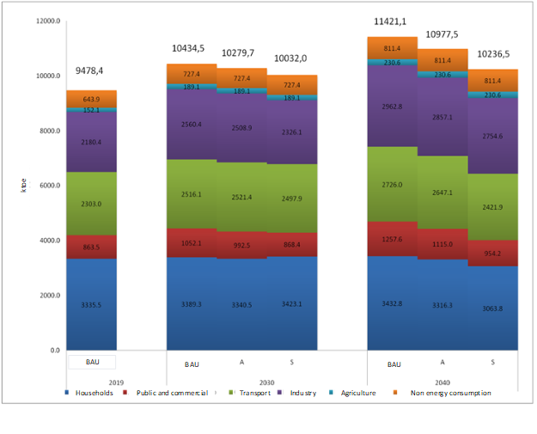
Figure 1. Projections of final energy consumption by sector

In the BAU scenario, the final energy consumption in the considered period increased from 9,478.4 ktoe in 2019 to 11,421.1 ktoe, which is the highest expected consumption during the considered period. Sector-wise, the highest consumption is in the household sector (35.2% in 2019 and 30.1% in 2040), industry (24.3% in 2019 and 23.9% in 2040), and transport (23% in 2019 and 25.9% in 2040). This structure remains unchanged during the considered period.
According to the assumptions of Scenario A, the final energy consumption will continue to increase and reach 10,977.5 ktoe in 2040. Expected consumption in 2040 will be about 4% lower than in the BAU scenario. The largest consumer is the household sector, whose share of consumption decreases from 35.2% in 2019 to 30.2% in 2040 due to the implementation of energy efficiency measures. Industry (23% in 2019 and 26% in 2040) and transportation (24.3% in 2019 and 24.1% in 2040) are the second and third largest consumer.
According to the assumptions of Scenario S, the final energy consumption will continue to increase and reach 10,236.5 ktoe in 2040. Expected consumption in 2040 will be about 11.5% lower than in the BAU scenario. The expected household consumption in 2040 of 3,063.8 ktoe is lower than in 2019 (3,335.5 thousand tons). Final consumption in other sectors is predicted to increase. Regardless of the predicted decrease in consumption during the analyzed period, households will still have the highest share of consumption (29.9% in 2040). The reduction in consumption is a result of energy efficiency measures and the intensive use of heat pumps for heating. The highest growth in energy consumption is predicted in the industry, from 2,180.4 ktoe to 2,754.6 ktoe, which is an increase from 23% to 26.9% in 2040. The predicted consumption in transport in 2040 is 2,421.9 ktoe.
Projections of the energy demand/final energy consumption by fuel are given at Figure 2. According to the assumptions of the BAU scenario, oil and petroleum products will have the largest share in final energy consumption, accounting for about 35%, which remains unchanged during the considered period. Electricity will follow with a share of around 25%, while the share of wood biomass will decrease from 16.6% to 14.6%.

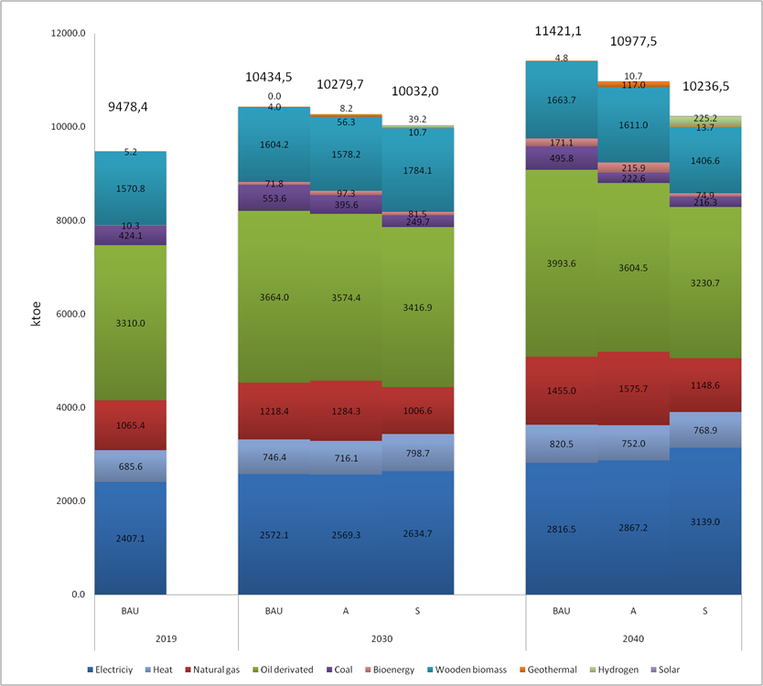
Figure 2. Projection of energy demand by energy source
Based on projections of Scenario A, oil and petroleum products will have the largest share in consumption during the considered period, decreasing from 34.9% in 2019 to 32.8% in 2040. Electricity will follow, with its share increasing from 25.4% to 26.1% due to the more intensive use of heat pumps, electric vehicles, and less intensive modes of transportation. The share of wood biomass will decrease, while the share of natural gas will increase.
According to projections in Scenario S, the demand for oil and petroleum products will increase from 3,310 thousand tons in 2019 to 3,230.7 thousand tons in 2040. The share of oil and petroleum products will decrease from 34.9% to 34.1% during the considered period. In absolute terms, the highest growth in consumption will be for electricity, from 2,407.1 thousand tons to 3,139 thousand tons in 2040, which is a growth in share from 25.4% to 26.3%. This increase is mainly caused by higher consumption of electricity in transport and for the operation of heat pumps in households and the public and commercial sectors.

3. RESULTS AND DISCUSSION

Emission of pollutants and GHG gases are obtained from the energy model developed for the Serbian energy sector. For the assessment of emission default emission factors for a specified fuel and specified sector were applied.

3.1 Carbon monoxide

The emission of carbon monoxide is influenced by the characteristics of fuel and by parameters of combustion (excess air, homogeneity of the mixture, combustion temperature, residence time). Combustion of the same fuel in different combustion surroundings will result in different emissions (for example combustion of natural gas in internal combustion engines and households results in different amounts of emission per unit of consumed energy). Results for carbon monoxide emission for three analyzed scenarios are given in Figure 3.
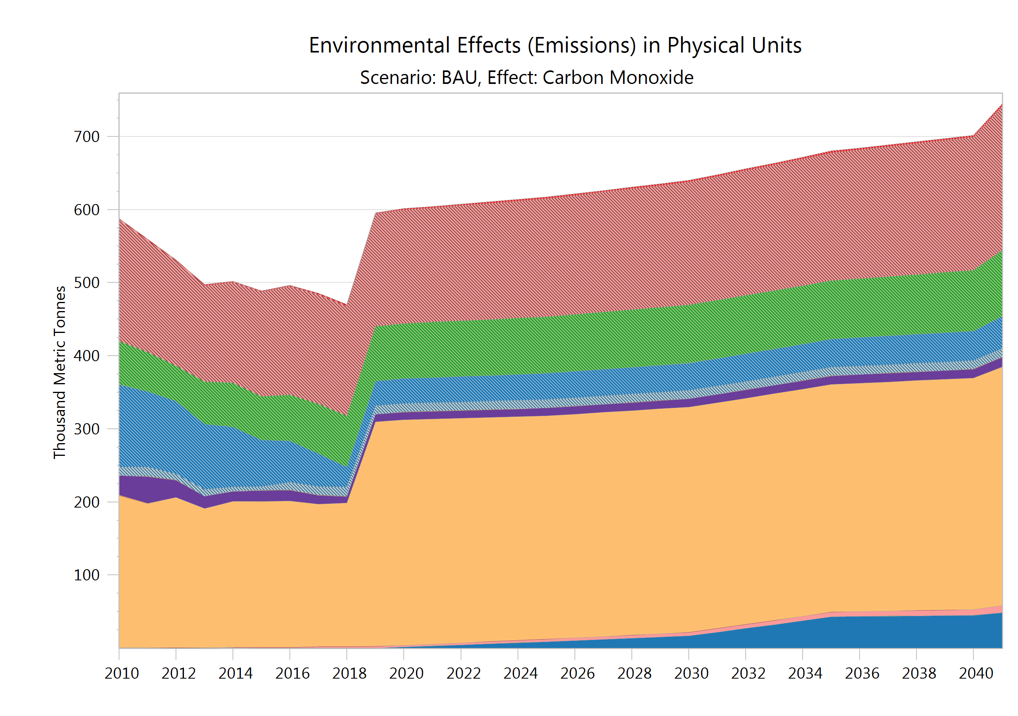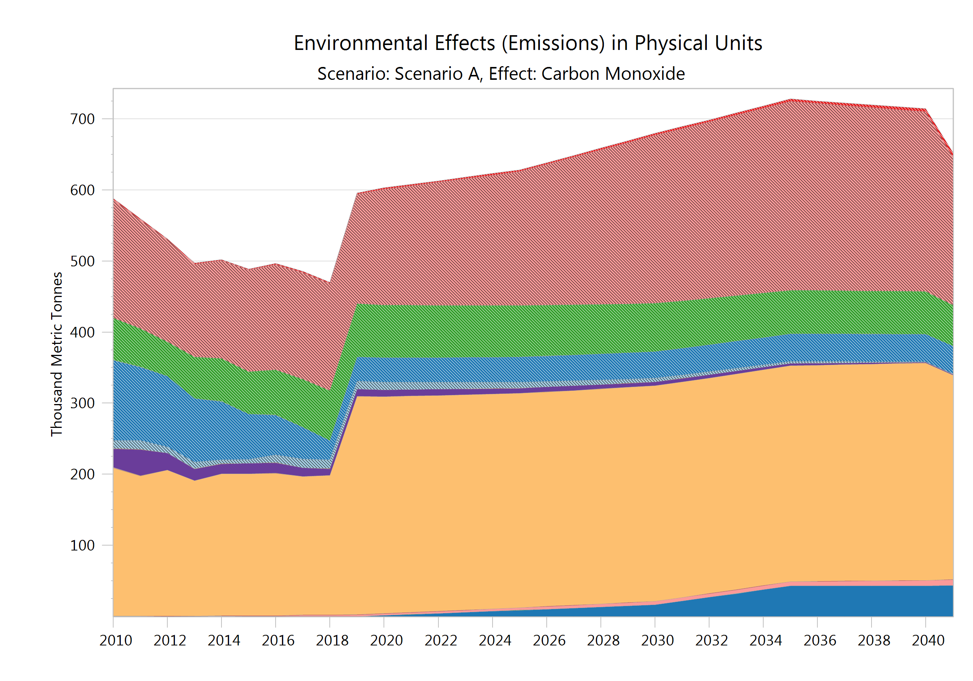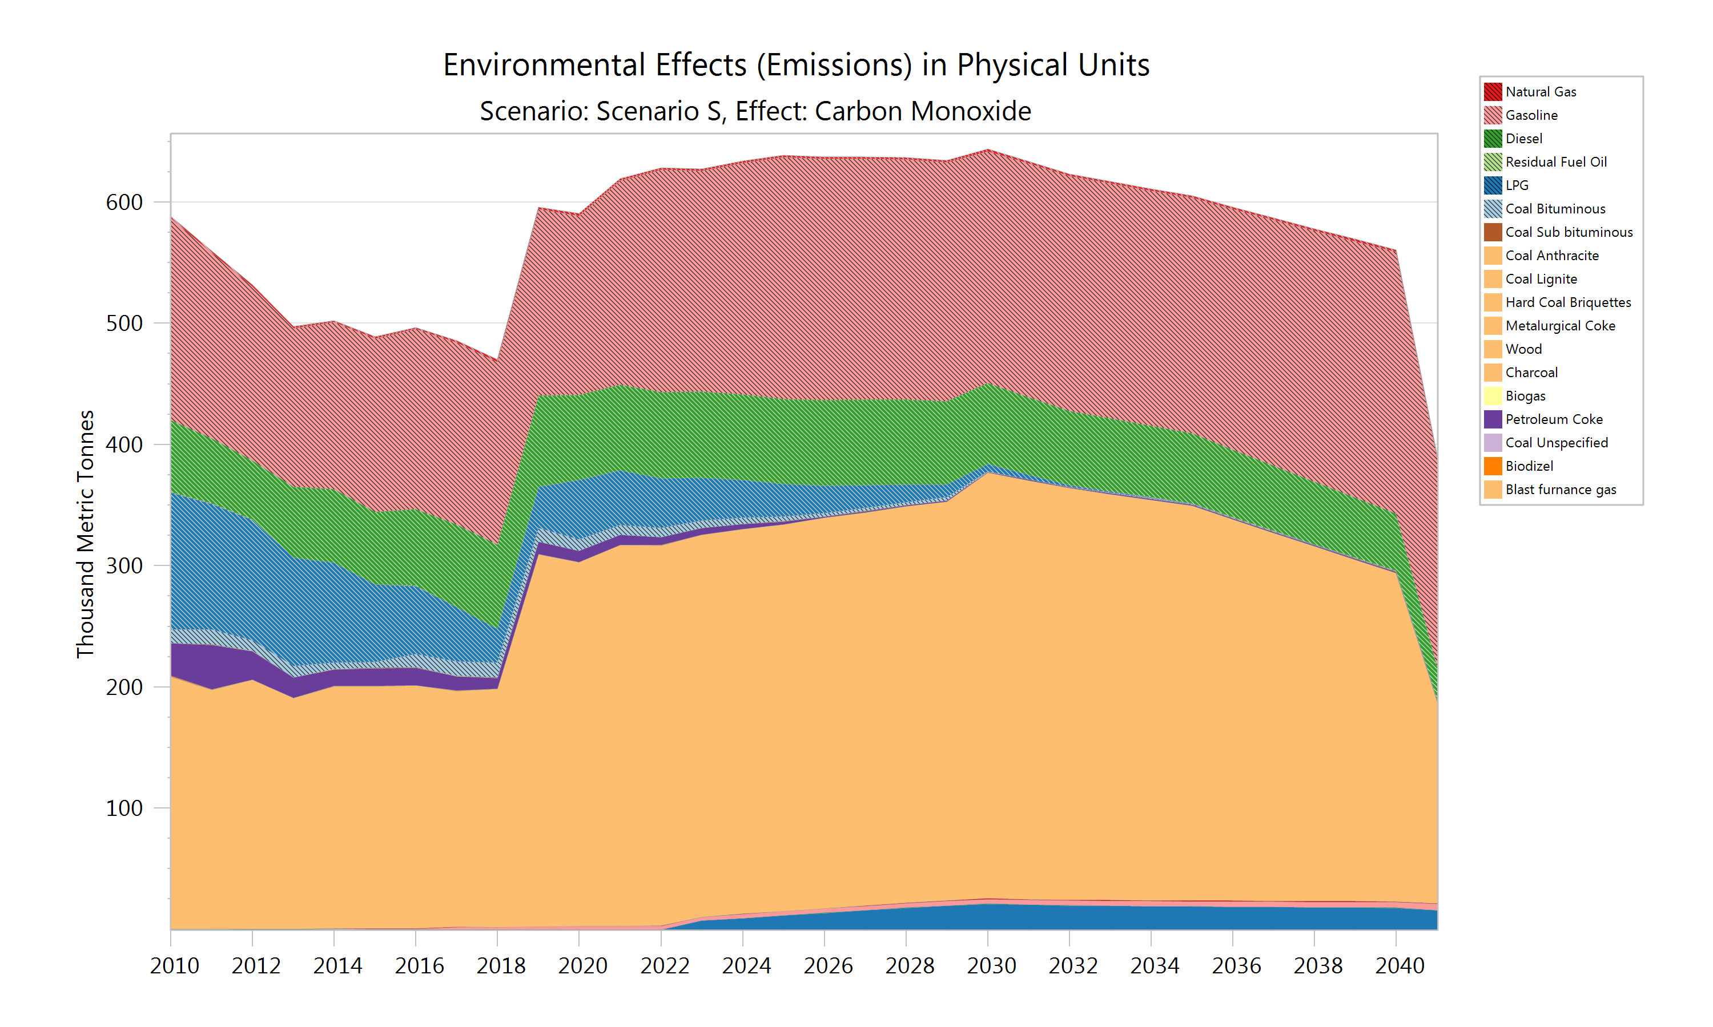
Figure 3. Carbon monoxide emission by fuel
The main sources of carbon monoxide emissions are gasoline and wooden biomass (firewood and pellet), and that is characteristic of all scenarios and throughout the whole analyzed period. Moderate ambition for conducting energy transition (Scenario A) will result in a reduction of approximately 1% compared with the BAU scenario in 2040. High ambition (Scenario S) would lead to a reduction of 21%, which assumes large penetration of heat pumps for individual heating and a ban on diesel internal combustion engines for passenger cars, the introduction of electric vehicles, biofuels, and hydrogen.

3.2. Nitrogen oxides

The emission of nitrogen oxides is dominantly influenced by the combustion temperature, excess air ratio, and homogeneity of the mixture. Fuel composition is relevant in terms of the number of carbon atoms in hydrocarbons, while the content of nitrogen in fuel is almost irrelevant. The projection of nitrogen emission resulting from combustion at end users is given in Figure 4. It is shown that during the whole analyzed period, the main source of nitrogen oxides emission will be from the transport sector due to combustion of diesel in internal combustion engines. Incomplete combustion with sub-stoichiometric conditions, a non-homogenous mixture with fuel rich zones accelerates nitrogen oxides formation. Total emissions in 2040 will be from 111.86 thousand tones in BAU, 98.73 thousand tones in Scenario A, and 74.73 thousand tones in Scenario S.
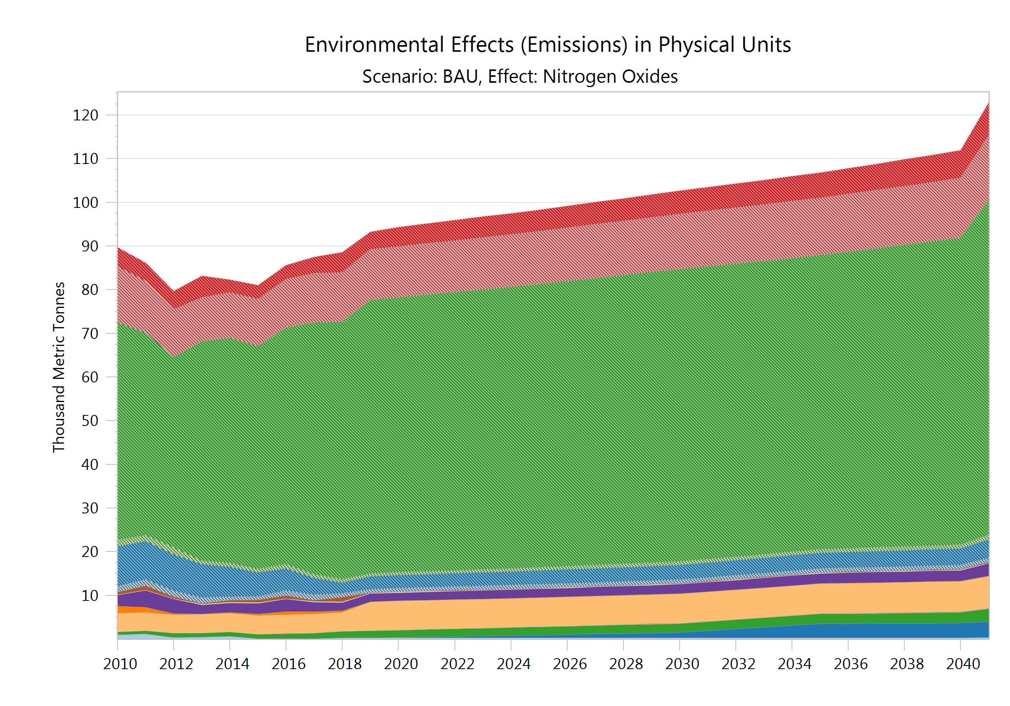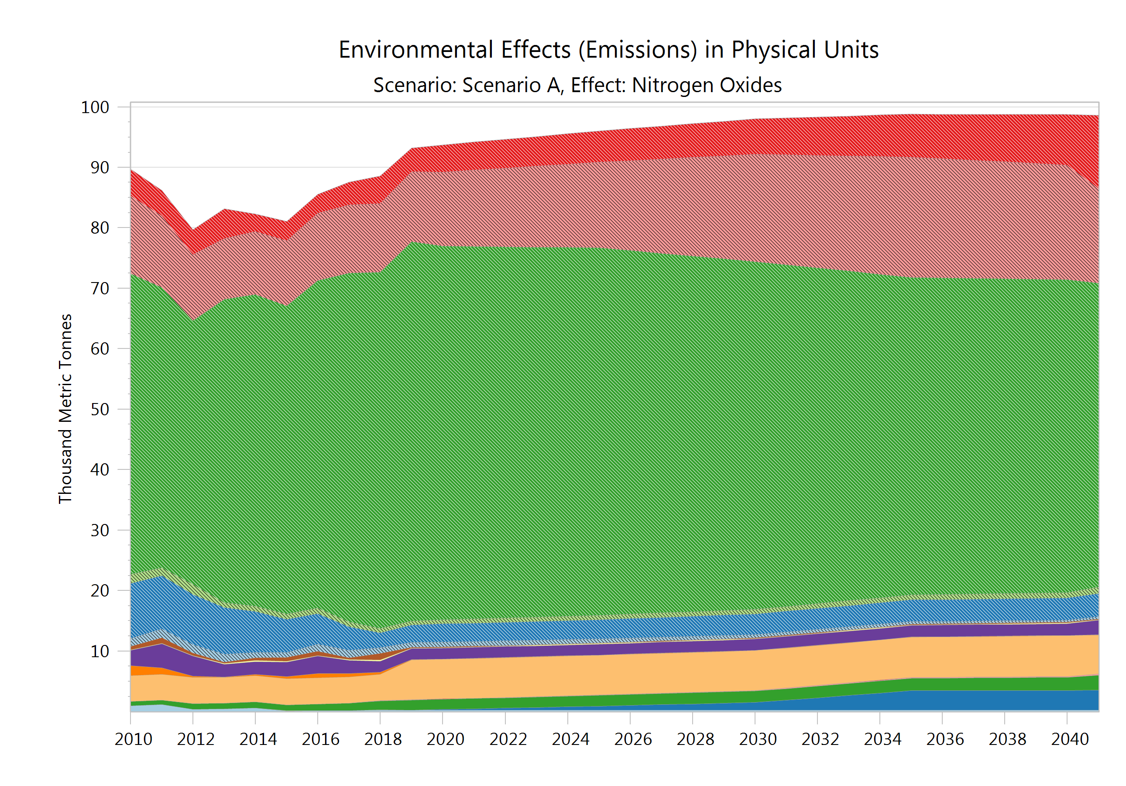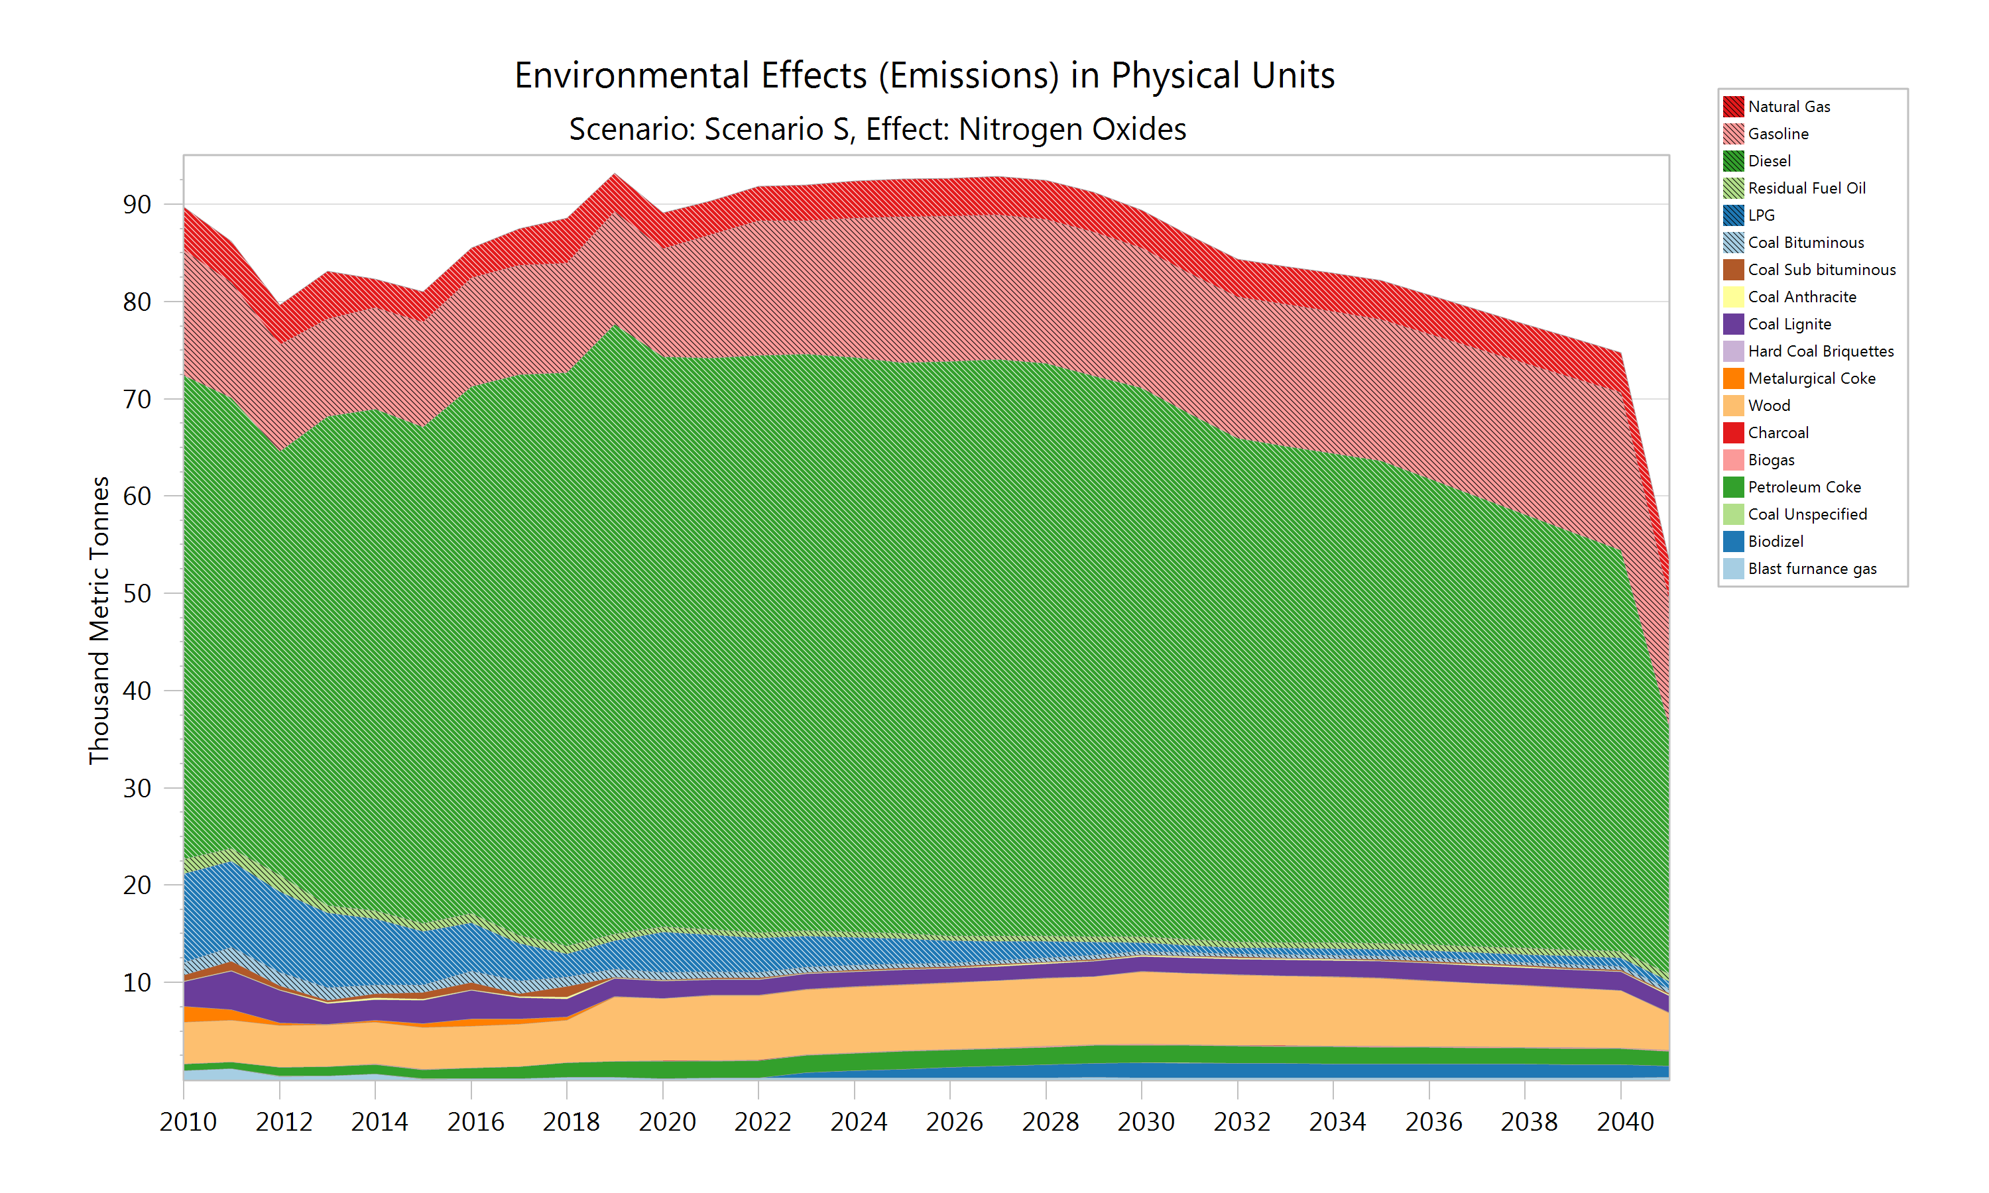
Figure 4. Nitrogen oxides emission by fuel
It should be kept in mind that the introduction of biofuels and hydrogen will result in nitrogen emission, which in the case of hydrogen could be higher than for oil derivates due to higher combustion temperature.

3.3. Non-methane volatile organic compounds

Non-methane volatile organic compounds (NMVOCs) are organic compounds, which may differ widely in their chemical composition, and that are emitted to the atmosphere during combustion processes. They are grouped as they display similar behavior in the atmosphere and are involved in the photochemical production of ozone and secondary organic aerosols in the atmosphere. Combustion of fossil fuels can be a substantial source of atmospheric benzene, including on and off-road transport, aviation, gas heating systems, and biomass burning. It is shown that moderate ambition for energy transition would lead to an increase of NMVOC emission by 8% in 2040, while implementation of highly ambitious measures would lead to a decrease of 7% in 2040, compared to BAU (Figure 5). As main sources of emission are incomplete combustion processes, from gasoline and diesel in the transport sector and wooden biomass in individual stoves and furnaces.

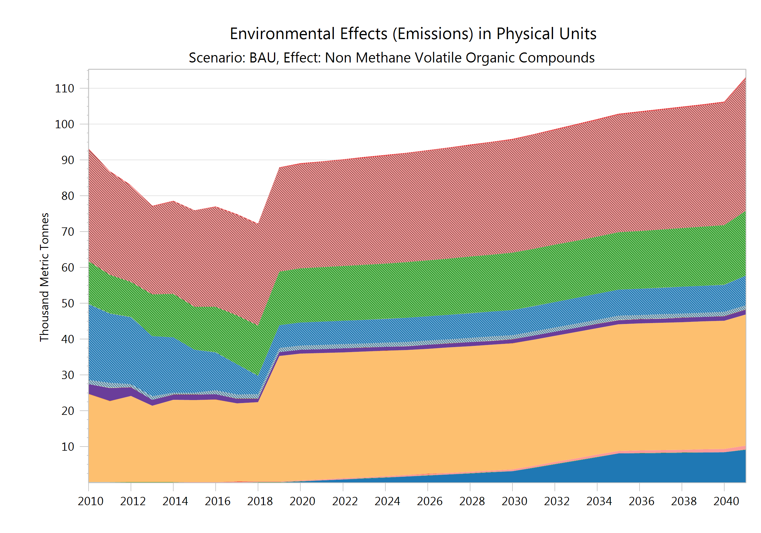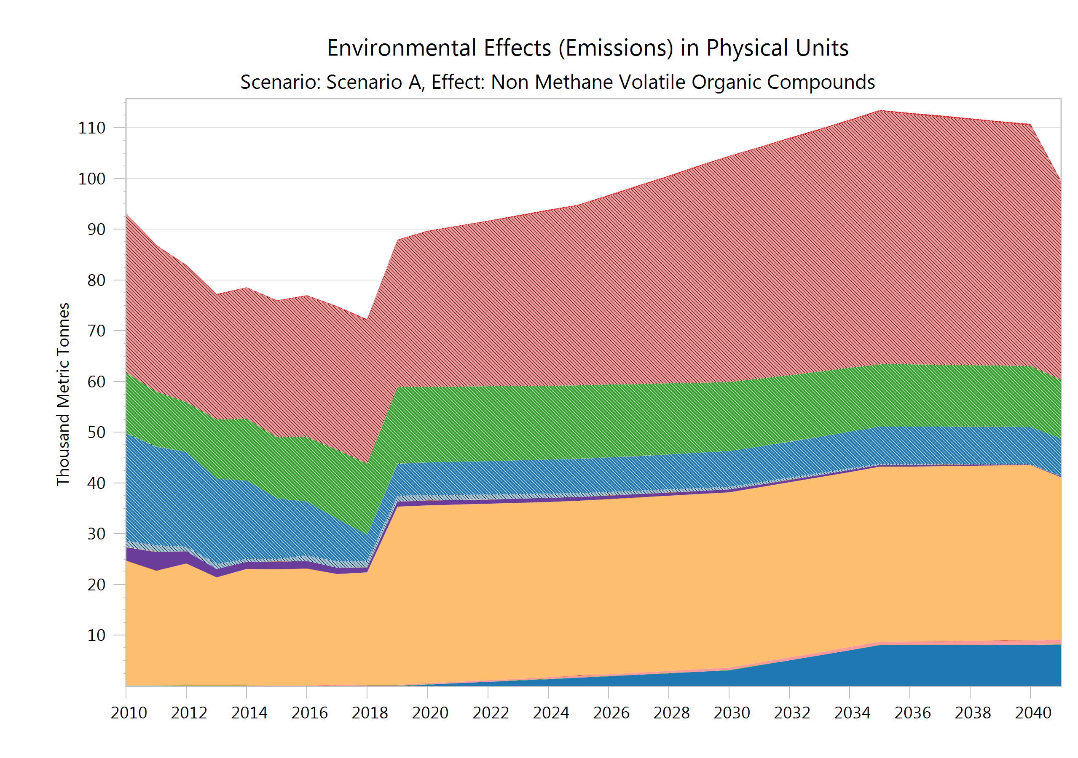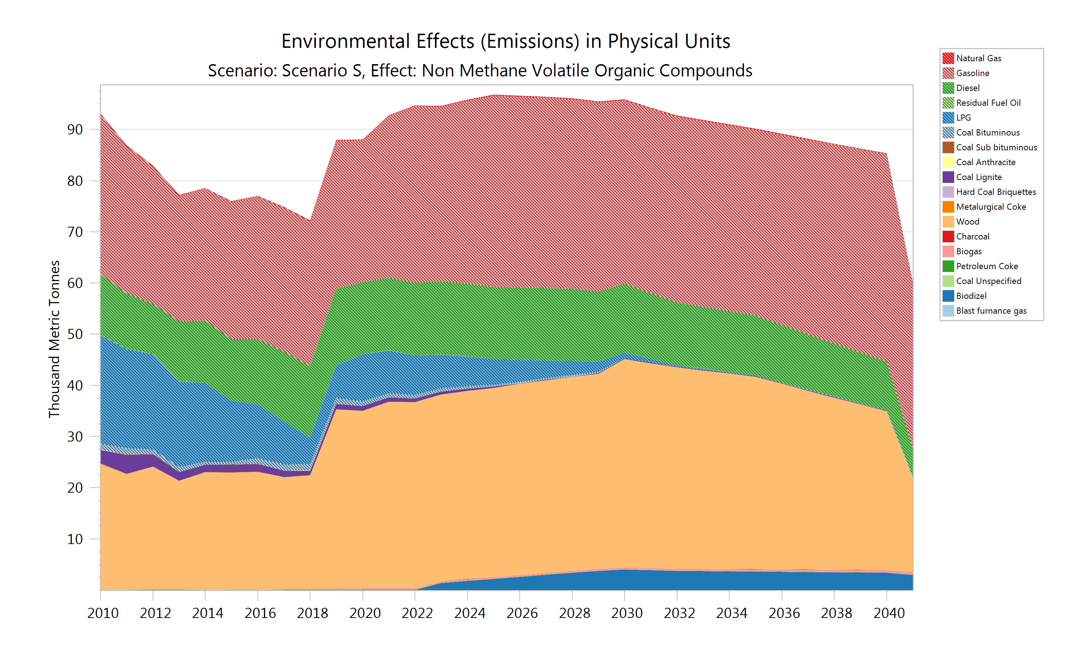
Figure 5. Non-methane organic compounds by fuel
3.4. Direct Carbon dioxide emission
Carbon dioxide emission is dependent only on fuel composition, and independent from combustion conditions. Projections of carbon dioxide emission are given in Figure 6. It is expected that emission will amount 14.94 million tons in BAU, 12.95 million tons in Scenario A, and 9.98 million tons n Scenario S.
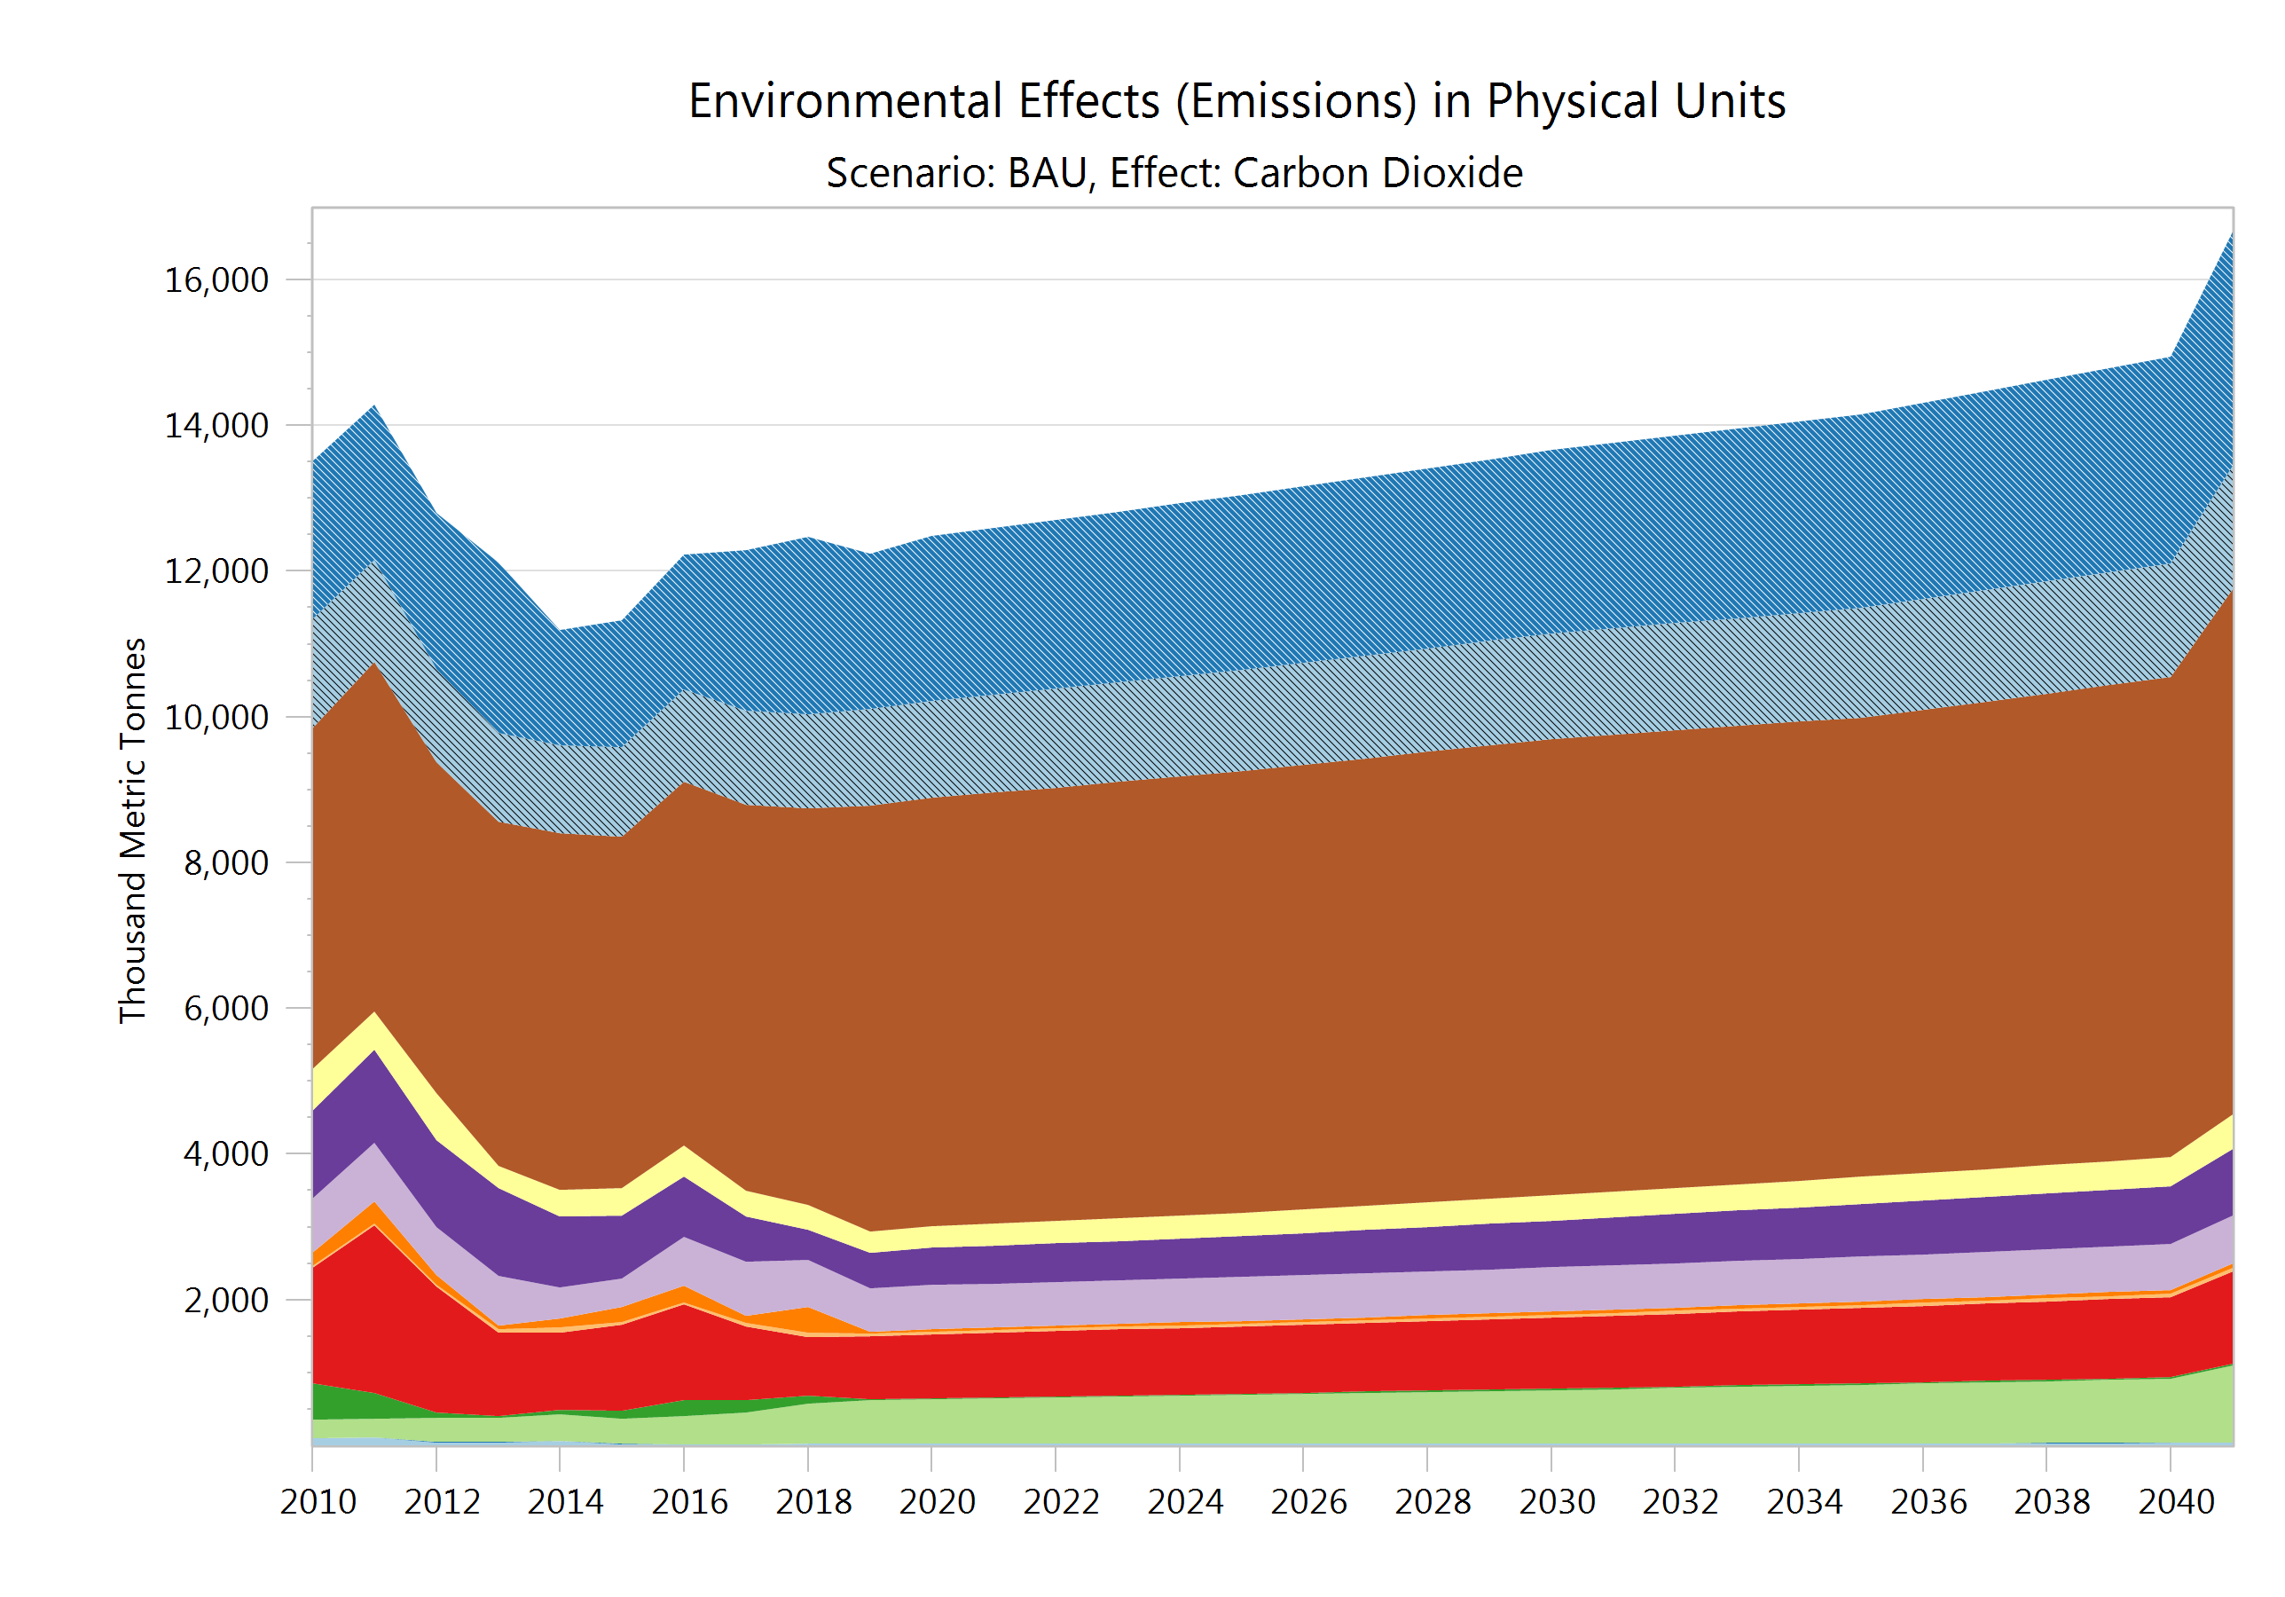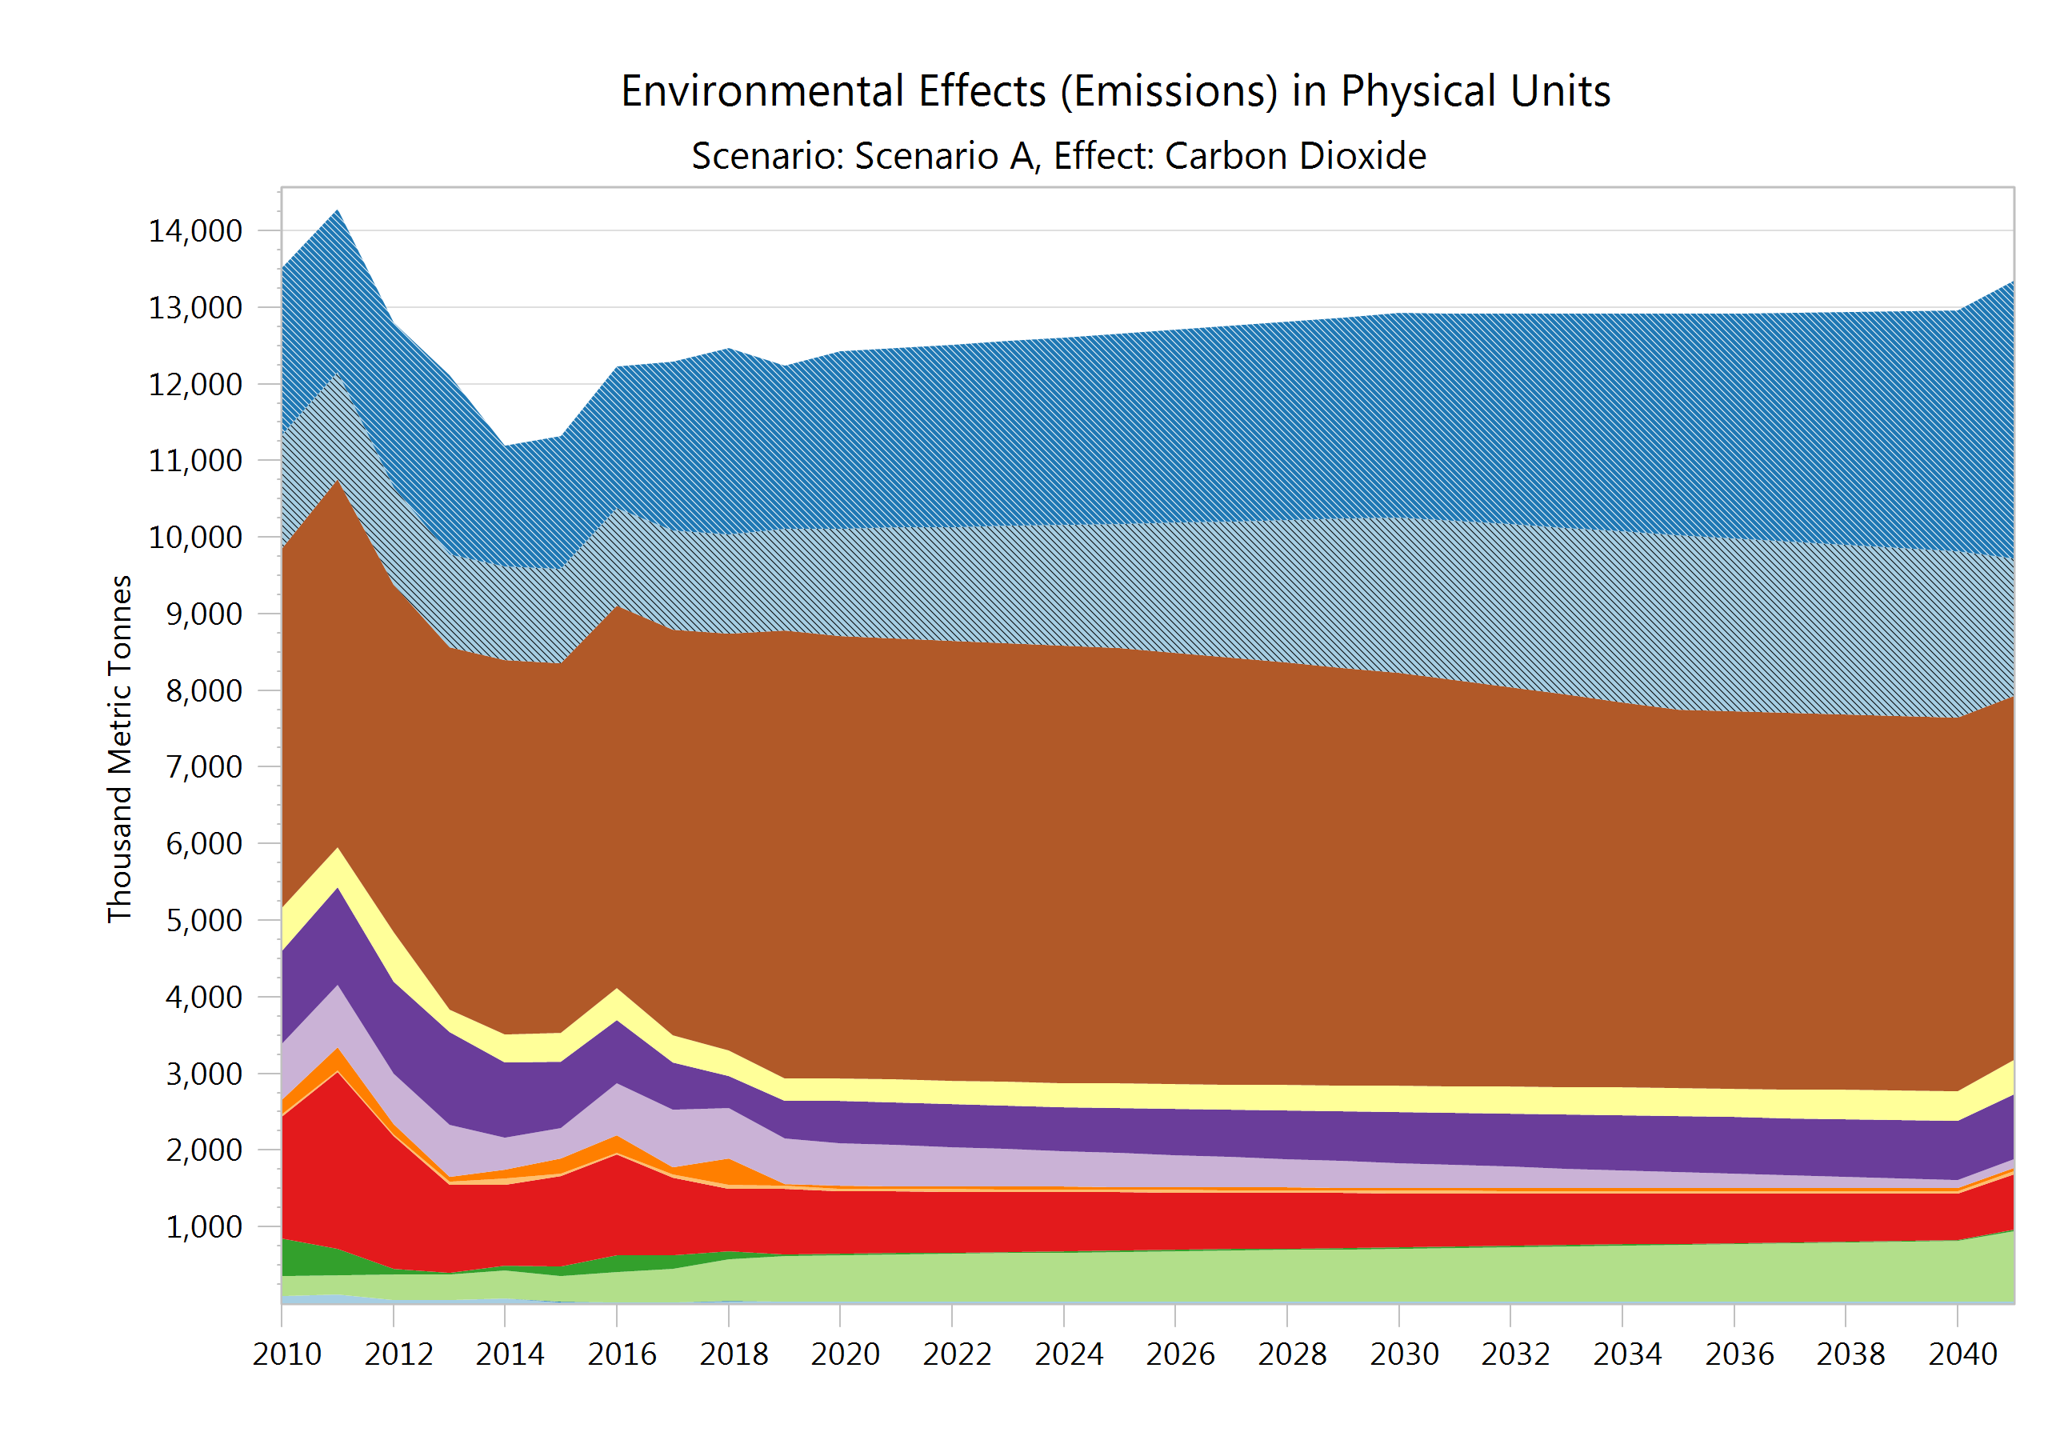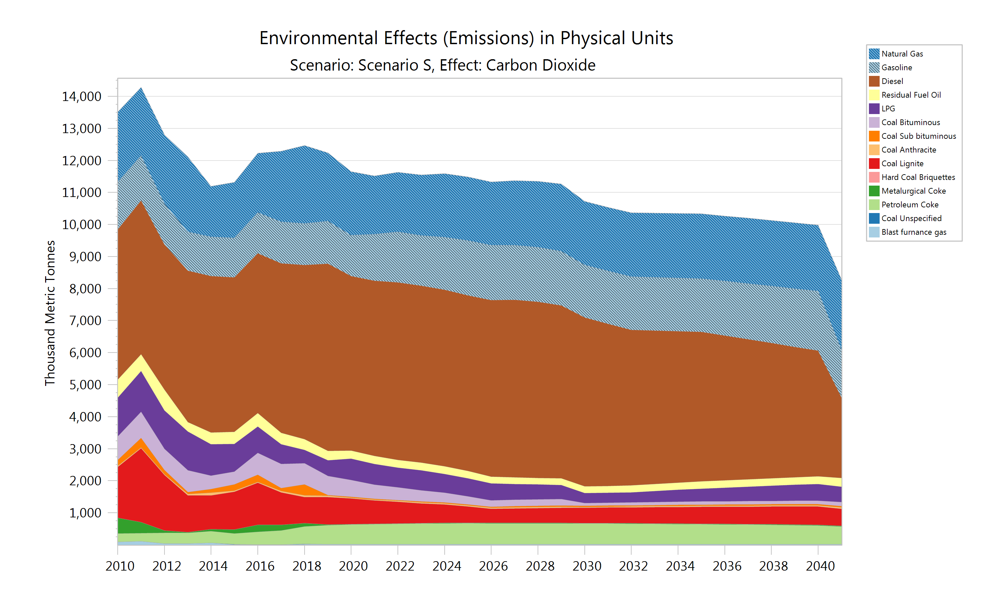
Figure 6. Direct carbon dioxide emission by fuel
4. CONCLUSION

Air pollution from energy is a global problem and challenge. As the primary contributor to air pollution, the energy sector must be at the forefront of action to improve air quality. Results of the simulation of possible future energy demand and associated pollutant emission are presented in order to explore the range of expected effects of fuel switching and implementation of energy efficiency measures. It can be concluded that even an ambitious transformation of energy system will result in very moderate results regarding pollutant emission.
A transition towards a more sustainable energy system is a challenging and hard task, driven mainly by ensuring the security of supply, affordability, and reduction of GHG emission. It is an impression that other harmful pollutants are put aside and that they still haven’t got to the focus. Reduction of GHG emission can be achieved by the introduction of biomass, but it should be kept in mind that it would be followed by increased emission of carbon monoxide, particulate matter, and NMVOC. The combustion of biofuels and hydrogen will cause emissions of nitrogen oxides and NMVOC, as well as emission of carbon monoxide in the case of biofuels.
There are no simple and quick solutions. Achieving acceptable levels of pollutant reduction will require a systematic approach that targets the residential and transport sectors, which consist of numerous heterogeneous consumers.

REFERENCES

- IRENA, International Renewable Energy Agency. Global Energy Transformation: A Roadmap to 2050. International Renewable Energy Agency, Abu Dhabi, 2018. Available online: https://www.irena.org/-/media/Files/IRENA/Agency/Publication/2019/Apr/IRENA_Global_Energy_Transformation_2019.pdf (accessed on 5 May 2023).
- Chen, B.; Xiong, B.R.; Li, H.; Sun, Q.; Yang, J. Pathways for sustainable energy transition. Journal of Cleaner Production, 2019, pp. 1564-1571, DOI: https://doi.org/10.1016/j.jclepro.2019.04.372.
- European Commission, Clean energy for all Europeans package. Available online: https://energy.ec.europa.eu/topics/energy-strategy/clean-energy-all-europeans-package_en (accessed on 5 May 2023).
- European Environmental Agency, Premature deaths due to air pollution continue to fall in the EU, more efforts needed to deliver a toxic-free environment. Available online: https://www.eea.europa.eu/en/newsroom/news/premature-deaths-due-to-air-pollution-continue-to-fall-in-the-eu-more-efforts-needed-to-deliver-a-toxic-free-environment (accessed on 5 May 2023).
- Republic of Serbia, Law on the use of renewable energy sources, Official Gazette of the Republic of Serbia, 40/21 and 35/23, Belgrade, 2021.
- Republic of Serbia, Law on Energy Efficiency and Rational Use of Energy, Official Gazette of the Republic of Serbia, 40/21, Belgrade, 2021.
- Republic of Serbia, Law on Climate Change, Official Gazette of the Republic of Serbia, 26/2021, Belgrade, 2021.
- Republic of Serbia, Energy Sector Development. Strategy of the Republic of Serbia for the period by 2025 with projections by 2030, Official Gazette of the Republic of Serbia, 101/2015, Belgrade, 2015.
- Republic of Serbia, Law on the Ratification of the Treaty on the Establishment of the Energy Community, Official Gazette of the Republic of Serbia, 62/2006, Belgrade, 2006.
- Heaps, C.G. LEAP: The Low Emissions Analysis Platform, Software version: 2020.1.56, Stockholm Environment Institute, 2022. Available online: https://leap.sei.org (accessed on 5 May 2023).
- National Bank of Serbia, GDP growth projection. Available online: https://nbs.rs/en/finansijsko_trziste/informacije-za-investitore-i-analiticare/podaci/projekcija_bdp/index.html (accessed on 5 May 2023).
- Statistical Office of the Republic of Serbia, Census of Population. Available online: https://popis2022.stat.gov.rs/en-US/ (accessed on 5 May 2023).

