Kosmaj monzogranite: New data from Radovac creek samples
Bojan Kostić, Danica Srećković-Batoćanin, Milica Maletić, Dejan Prelević, Suzana Erić
University in Belgrade, Faculty of mining and geology, Djušina 7, 11000 Belgrade
e-mail: bojan.kostic@rgf.bg.ac.rs

Key words: Kosmaj, monzogranite, geothermobarometry, U-Pb age
Intensive tectonic movement and instability of the Dinaride orogen through the Savian orogeny phase initiated the emplacement of Kosmaj granitoid into the Upper Cretaceous sediments giving rise to derivation of contact-metamorphic rocks. Different varieties of hornfels, and less abundant skarn occur on the western and north-western slopes of Kosmaj. Small outcrops of granitoid pluton are exposed also on the north-western slopes of the Kosmaj Mts., which is located within the Vardar Zone composite terrane. The magmas of these granitoid rocks have potassic signature and their primary origin is crustal (Vasković, 1987). Macroscopic and microscopic analysis of samples revealed monzogranite with a granular to porphyroid texture made of orthoclase, plagioclase, quartz, biotite, and amphibole (fig. 1). The appearance of sericite, epidote and chlorite indicates an alteration caused by surface decomposition (weathering). Feldspar analyzes show that K-feldspar contains from 82.5 to 87.4 % orthoclase (potassium) component, while plagioclase with 59.4 to 72.1 % albite component considers andesine. Biotite does not display significant differences in alumina, iron, and magnesium contents, having Mg number between 0.588 and 0.622. All of the analyzed amphibole grains consider Ca amphiboles, i.e., magnsio-hornblende (Leake et al., 1997).

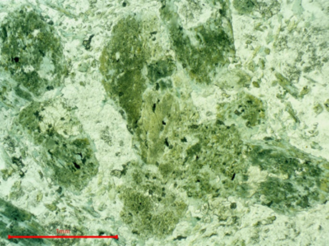 | 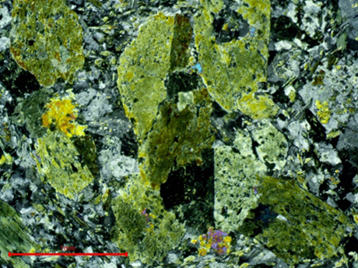
Figure 1: Granular texture of monzogranite and a group of larger hornblende crystals compared to feldspars grains (left PPl, right XPL).

Based on the amphibole-plagioclase geothermobarometric calculation (e.g., Blondy & Holland, 1990), a temperature of 728 ºC and a pressure of 1.4 Kbar were obtained, representing the PT conditions (fig. 2) during the emplacement of Kosmaj monzogranite and indicating shallow-level emplacement.

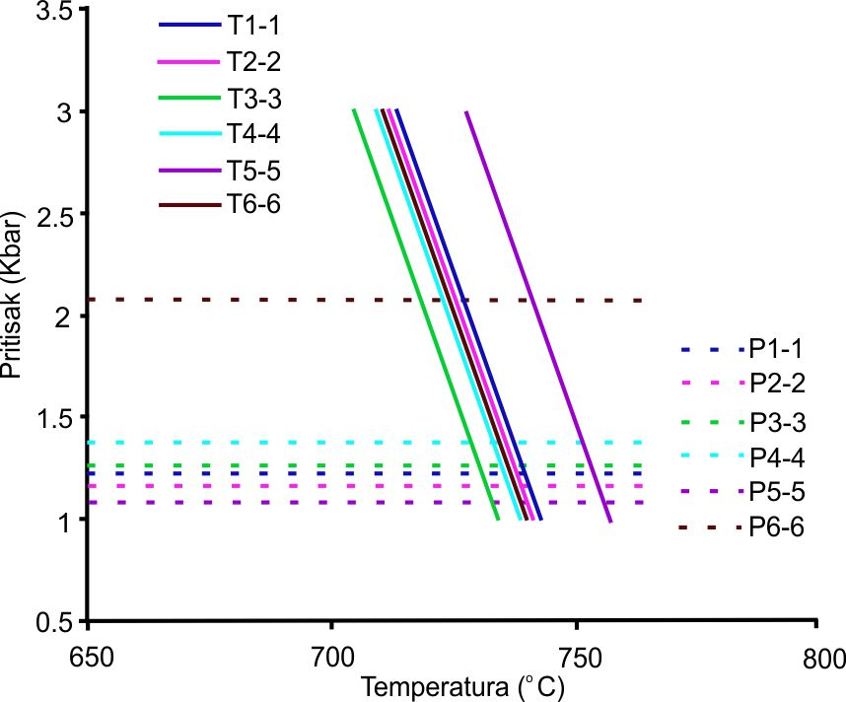
Figure 2: PT conditions diagram of crystallization Kosmaj monzogranite

The radiometric U-Pb method on zircons suggests that Kosmaj monzogranite was emplaced during the late Oligocene, with an absolute age of 25.95 ± 1.2 Ma (fig. 3).

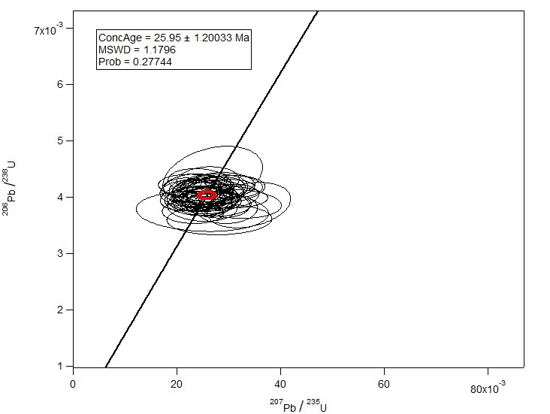
Figure 3. Isotopic U-Pb age of zircons from Kosmaj monzogranite on concordia diagram

References

- Blundy, J.D. Holland, T.J.B., 1990. Calcic amphibole equilibria and a new amphibole-plagioclase geothermometer, Contribution to Mineralogy and Petrology, 104, 208-224.
- Leake, B.E. 1997. Nomenclature of Amphiboles: Report of the Subcommittee of the International Mineralogical Association, Commission on New Minerals and Mineral Names. American Mineralogist, 82, 1019-1037.
- Vasković, N. 1987. Petrološke karakteristike moncogranita Kosmaja – radovi Geoinstituta, kniga 20, Beograd, 91-113

